PERFORMANCE REPORT
Auto Ticket Classification using Flow Designer
ServiceNow System Administrator
Project Name | Auto Ticket Classification using Flow Designer
Team Lead | Pavithran B
Team Members | Poovendhiran C R, Rajasekara Babu, Prabhakaran M, Vishnu Priyan
Report Date | 03 October 2026
Team ID | SWTID-2026-9936
Data notice. The test tickets are sample inputs written for this report, and the classification results were produced by running the project's documented keyword rules on them (case-insensitive 'contains' matching). The processing time and manual triage time are assumed values. Before submitting, replace them with measurements from your own ServiceNow instance (see section 7).

1. Objective and Scope
This report evaluates the overall performance of the Auto Ticket Classification flow built in ServiceNow Flow Designer. It checks how accurately tickets are classified by keyword, how much manual triage time the automation saves, and where the current rules can be improved.
In scope: the four keyword rules (Wi-Fi / Network, Projector, Password, Slow), the dependent Category and Subcategory values, and the confirmation email. Out of scope: assignment automation, SLA tracking and load testing of the instance.

2. Performance Inputs
The inputs below are what is needed to measure performance for this project.
Input | Description | Value used | Type
Test ticket set | Short Descriptions a student or faculty member might type | 24 tickets: 6 Network, 5 Hardware, 5 Access, 5 Performance, 3 out-of-scope | Sample
Keyword rules | Rules as configured in the flow | Wi-Fi / Network, Projector, Password, Slow | From project
Expected result | Correct Category for each test ticket | Set by the team for each ticket | Sample
Ticket volume | Tickets received per day | 50, 100, 200, 500 | Scenario
Manual triage time | Staff time to read and categorise one ticket | 150 seconds | Assumed
Flow processing time | Time from ticket creation to Category set and email sent | 3 seconds | Assumed
Targets | Pass marks used in the scorecard | Accuracy 90% or more, wrong category 0%, unclassified 10% or less, processing 10 s or less | Chosen

3. Metrics and Method
Metric | Meaning | How it is calculated
Classification accuracy | Share of test tickets given the expected result | Correct results / 24 tickets
Wrong-category rate | Tickets put in the wrong category | Wrong results / 24 tickets
Unclassified rate | In-scope tickets the flow left without a category | Missed in-scope tickets / 21 in-scope tickets
Processing time | Time the flow takes per ticket | Assumed 3 s; measure in Flow Designer executions
Staff triage time | Hours of manual work left per day | Volume x 150 s x share of tickets not classified
Two versions of the rules were compared: the baseline rules exactly as configured in the project, and an improved version that adds common spellings and synonyms (wifi, internet, pwd, log in, sign in, login, hang, freeze).

4. Results: Classification

4.1 Test ticket results
# | Short Description | Expected | Baseline | With variants
1 | WiFi not working in library | Network | Miss | Pass
2 | Wi-Fi is disconnected in lab 2 | Network | Pass | Pass
3 | Network down in staff room | Network | Pass | Pass
4 | My college has issue with Network | Network | Pass | Pass
5 | Wi-Fi signal very weak in classroom | Network | Pass | Pass
6 | No internet in hostel block | Network | Miss | Pass
7 | Projector not turning on | Hardware | Pass | Pass
8 | Projector display is blurry in seminar hall | Hardware | Pass | Pass
9 | Projector remote not working | Hardware | Pass | Pass
10 | Project is not turnning on | Hardware | Miss | Miss
11 | Need a new projector bulb for hall 3 | Hardware | Pass | Pass
12 | Forgot my Password for student portal | Access | Pass | Pass
13 | Password reset needed for college email | Access | Pass | Pass
14 | Password expired, cannot sign in | Access | Pass | Pass
15 | Unable to log in to LMS | Access | Miss | Pass
16 | Reset my pwd | Access | Miss | Pass
17 | Computer is very slow | Performance | Pass | Pass
18 | Slow system in computer lab | Performance | Pass | Pass
19 | Laptop running slow after update | Performance | Pass | Pass
20 | Lab PC hangs frequently | Performance | Miss | Pass
21 | Systems are slow during online exam | Performance | Pass | Pass
22 | Printer out of paper | No category | Pass | Pass
23 | Request for a new desk in office | No category | Pass | Pass
24 | Need guest access card for visitors | No category | Pass | Pass
A 'Pass' on an out-of-scope ticket means the flow correctly left it without a category. Every miss in this set is a ticket the flow left unclassified; no ticket was placed in a wrong category.

4.2 Summary
Measure | Baseline rules | With variants
Correct results | 18 of 24 (75.0%) | 23 of 24 (95.8%)
Wrong category | 0 of 24 (0%) | 0 of 24 (0%)
Unclassified in-scope tickets | 6 of 21 (28.6%) | 1 of 21 (4.8%)
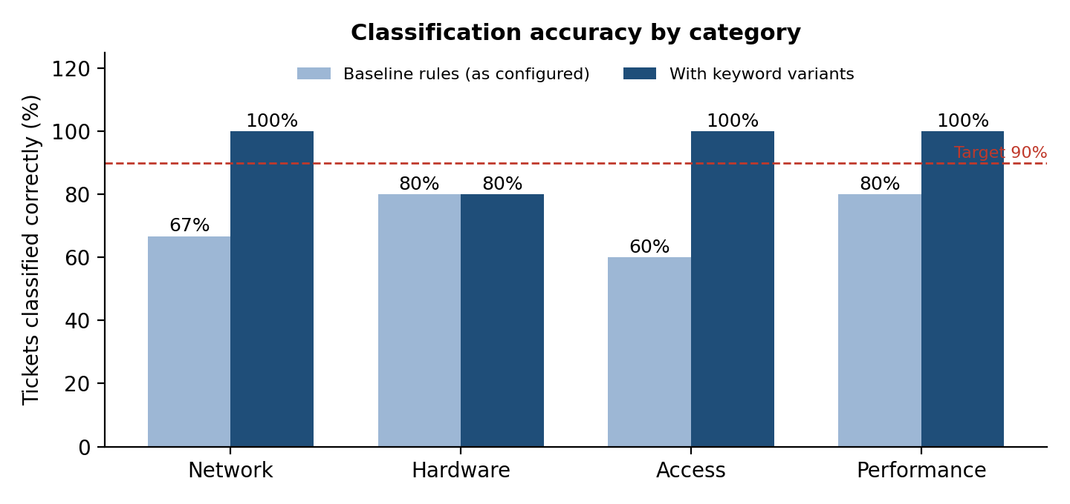
Figure 1: Share of tickets classified correctly, by category

5. Results: Time Saved
With manual triage, every ticket needs about 150 seconds of staff time. With the flow, only tickets that are not classified still need a person. The chart shows the staff triage hours left each day at four ticket volumes.
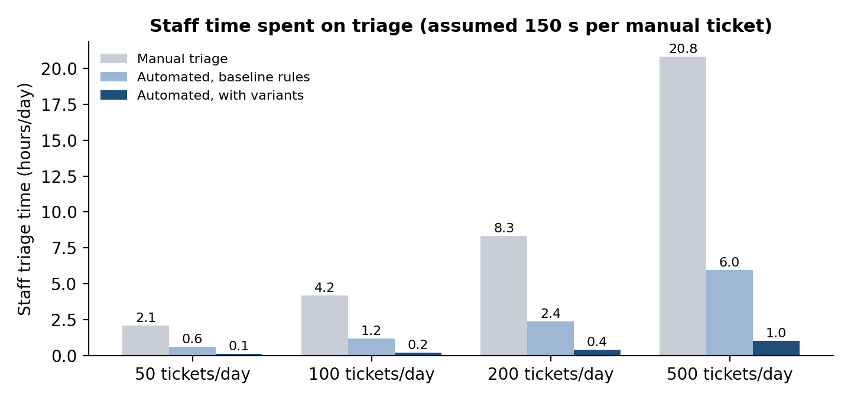
Figure 2: Staff time spent on triage per day (assumed values)
At 100 tickets a day, manual triage takes about 4.2 hours. The baseline rules reduce this to about 1.2 hours, and the improved rules to about 0.2 hours, a saving of roughly 95%. At an assumed 3 seconds per ticket, the flow itself uses about 5 minutes a day at this volume.

6. Overall Performance Scorecard
Metric | Target | Baseline | With variants | Status (baseline / variants)
Classification accuracy | 90% or more | 75.0% | 95.8% | Not met / Met
Wrong-category rate | 0% | 0% | 0% | Met / Met
Unclassified in-scope tickets | 10% or less | 28.6% | 4.8% | Not met / Met
Flow processing time (assumed) | 10 s or less | 3 s | 3 s | Met / Met
Staff triage time at 100 tickets/day | Lower than manual (4.2 h) | 1.2 h | 0.2 h | Met / Met
Confirmation email per ticket | 1 per ticket | Sent in recorded test | Sent in recorded test | Met / Met
The email result comes from the recorded test in the project report (confirmation email previewed in System Logs > Emails). It was not part of the simulated ticket set.

Findings
- The rules are precise but miss many spellings. No ticket was put in a wrong category, but 6 of 21 in-scope tickets were left unclassified by the baseline rules (28.6%).
- Spelling and wording cause the misses. 'WiFi' without a hyphen, 'log in', 'pwd' and 'hangs' did not match any keyword. The typo 'Project' instead of 'Projector' is missed even by the improved rules.
- Keyword variants raise accuracy from 75.0% to 95.8% with no change to the design of the flow.
- Out-of-scope tickets (printer, desk, guest card) correctly get no category, but there is no 'Other' category for staff to find them quickly.

Recommendations
- Add the spelling variants and synonyms to the flow conditions (Wi-Fi, WiFi, internet, pwd, log in, sign in, hang, freeze).
- Add an 'Other' category so unclassified tickets are easy to filter and route.
- Review unclassified tickets every month and add new keywords from them.
- Add Assigned group automation per category to remove the remaining manual step.

7. How to Replace the Sample Values with Real Measurements
- Create the 24 test tickets in the Incident WorkFlow form and record the Category and Subcategory the flow sets for each one.
- Open Flow Designer > Executions to read the run time of each execution and use the average as the flow processing time.
- Check System Logs > Emails to confirm one confirmation email per ticket.
- Time a staff member triaging 10 tickets by hand and use the average as the manual triage time.
- Update the tables and charts with these numbers.

8. Conclusion
The Auto Ticket Classification flow never misplaced a ticket in the sample test and removes most of the manual triage effort. With the rules as configured it classified 75.0% of the sample tickets correctly. Adding keyword variants raises this to 95.8% and cuts staff triage time at 100 tickets a day from about 4.2 hours to about 0.2 hours. The design meets its goals for a school IT helpdesk and can be improved further with spelling variants, an Other category and assignment automation.

